**KNJIGE O ENGLESKIM NAVIJAČIMA**

1. **Armed for the match** - Steven Hickmott, Colin Ward -- polovna „Very Good“ cena 1350.00din

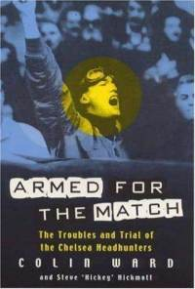

1. **Blades Business Crew** - Steve Cowens---- polovna „Very Good“ cena 1350.00din

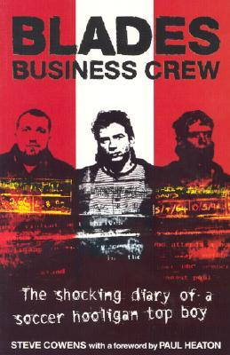

1. **Blades Business Crew 2 -** Steve Cowens- polovna „Very Good“ cena 1350.00din

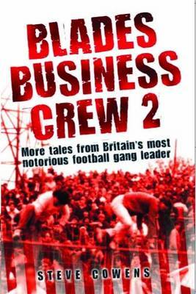

1. **Soul Crew** - Tony Rivers, David Jones --- nova 1250.00din

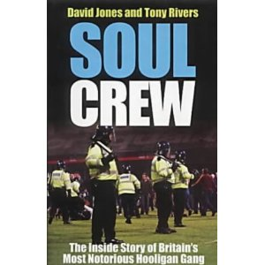

1. **Bovver** - Chris Brown --- - polovna „Very Good“ cena 1350.00din



6. **Derby days** - Dougie and Eddy Brimson - polovna „Very Good“ cena 1250.00din

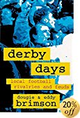

7. **Red Army General** - Tony O Neill - polovna „Very Good“ cena 1250.00din



8. **The Men in black** – Tony O Neill- polovna „Very Good“ cena 1250.00din

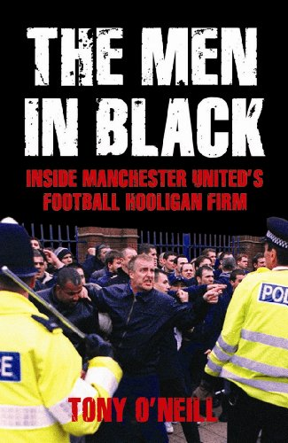

9. **WHO WANTS IT?** - Colin Ward and "Chubby" Chris Henderson- polovna „Very Good“ cena 1450.00din

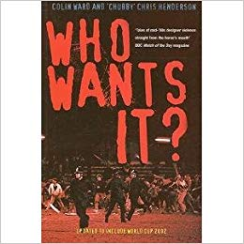

10. **The boys from the Mersey** – Nicky Allt --- polovna „Very Good“ cena 1250.00

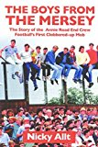

11. **Naughty** – Mark Chester – nova 1350.00din

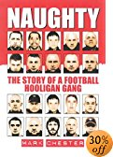

12. **Gilly** – Gilroy Shaw with Martin King--- polovna „Very Good“ cena 1250.00

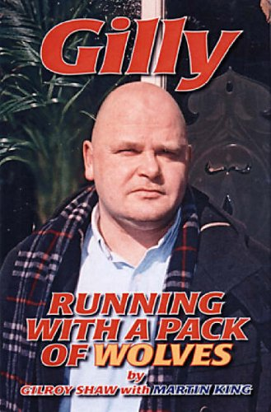

13. **Want some aggro –** Cass Pennant Micky Smith – nova 1100.00din

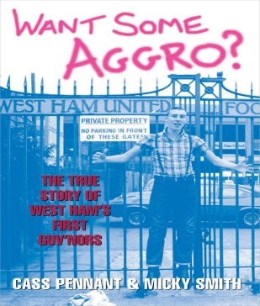

14. **Scally –** Andyy Nicholls – nova 1350.00din

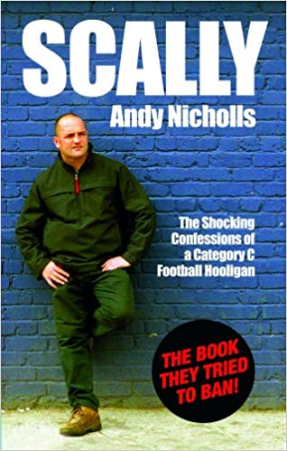

15. **657 Crew – Cass Pennant,** Rob Silvester --- nova 1250.00din

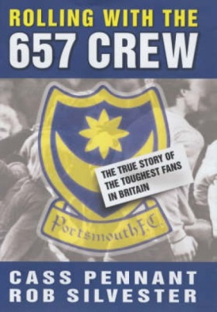

16**. Hooligans** – Nick Lowles and Andy Nichols – nova 1250.00

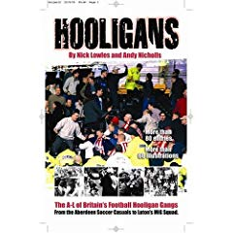

17. **Hooligans 2** - Nick Lowles and Andy Nichols --- polovna „Very Good“ cena 1250.00

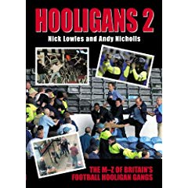

18. Top boys – Cass Pennant -- -nova 1950.00din

